Young Carers Policy
Victoria Road Primary School

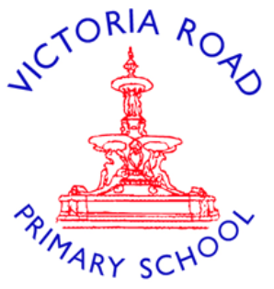

Written on: February 2026
Next review due by: February 2027
Approved by Headteacher
This policy outlines how Victoria Road Primary School identifies and supports pupils who are Young Carers. We are committed to ensuring that Young Carers have the same access to education and future opportunities as their peers.
1. Definition
A Young Carer is a child or young person under the age of 18 who provides care, assistance, or support to another family member who has a physical or mental illness, a disability, or a substance misuse issue.
2. Our Guiding Principles
At Victoria Road Primary School, we believe that:
- Every child matters: Being a Young Carer should not be a barrier to learning or happiness.
- We See You: We aim to identify Young Carers as early as possible to prevent them from falling behind.
- We Support You: We provide a "whole school" approach, ensuring all staff understand the unique challenges these pupils face.
3. Key Support Roles
- Young Carers Leads: Mrs. Lewis and Mrs. Vincent.
- Role Responsibilities: * Act as the main point of contact for Young Carers and their families.
- Maintain an up-to-date register of Young Carers.
- Liaise with external agencies and local Young Carers services.

4. Identification and Support
- We recognize that Young Carers may experience barriers such as tiredness, isolation, and difficulty completing homework. To support them, we provide:
- Dedicated Young Carers Club: A safe, weekly space to meet others in similar situations, share experiences, and have fun.
- Time To Talk: Designated time for pupils to speak with Mrs. Lewis or Mrs. Vincent for emotional support and advice.
- Quiet Space: Access to a "Calm Zone" during break or lunch if a pupil feels overwhelmed or needs a moment of rest.
- Homework Flexibility: Understanding and extra time for assignments when home life is particularly demanding.
- External Links: Referrals to local authorities and charities for workshops, trips, and additional family support.

5. Staff Training
All staff will receive regular training to:
- Recognize the signs of a pupil who may be a Young Carer (e.g., frequent lateness, anxiety, or social withdrawal).
- Understand the sensitivity required when discussing a pupil’s home situation.
- Know how to refer a child to the Young Carers Leads.
6. Confidentiality
We respect the privacy of our families. Information regarding a Young Carer's home life will be shared only with relevant staff on a "need-to-know" basis to ensure the child’s safety and wellbeing, in accordance with our Safeguarding Policy.
7. Communication with Parents/Carers
We strive to build strong, non-judgmental relationships with parents. We will:
- Ensure that the Young Carer's status is considered during parent-teacher meetings.
- Offer support to the parent/guardian to help minimize the impact of the caring role on the child’s education.

Policy Review Date: February 2027

